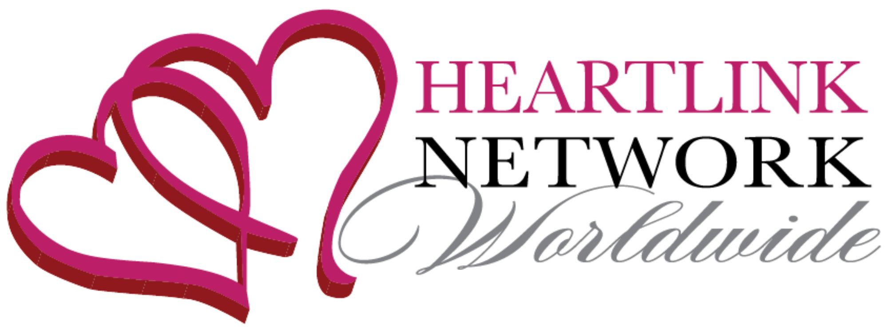

The [Enter Chapter Name] Chapter Invites You!

Heart Link Worldwide attracts high integrity entrepreneurial women around the globe who are heart-centered, driven, collaborative and possess a mutual respect and desire to support one another. Founded in 2007, we continue to be dedicated to enhancing the businesses and the lives of entrepreneurial women by uniting, networking, collaborating, nurturing, mentoring, and providing opportunities for our members to gain more visibility, grow their business skills and attract quality leads. We are committed to linking women from the heart and supporting genuine connections that build prosperity through meaningful and strategic relationships.

Whether you are an entrepreneur, business owner, service provider, community leader, non-profit organizer, you are just starting your business journey, or are a seasoned professional, we collectively deliver a wealth of experience and capabilities to help you accelerate your business growth.

Join Us at Our Next Business Networking Event
Date of Event: [DATE OF EVENT]
Time: [TIME OF EVENT]
Location: [LOCATION NAME AND ADDRESS]
RSVP: VENMO to [CHAPTER LEADER’S VENMO]
Email: [EMAIL ADDRESS]
For more information contact [ENTER NAME AND PHONE NUMBER OF CHAPTER LEADER]
Events are company-exclusive and industry inclusive. Your pre-payment is your reservation.

♥ Heart Link Network Worldwide Core Values ♥
Friendship First We Complete Not Compete Always Add Value
Abundance Mentality We Rise by Lifting Others

